# Problem #3 – DataWarehouse

PetUniversity is an institution for pets and their owner to enroll in training courses, we are building a pet data warehouse to move the operational reporting analysis from transactional system to the data warehouse for all their reporting needs.

* PetUniversity enrolls pets of different types - dogs, cats, birds, horses. Pets and their owners have to together enroll in the courses.
* Each course starts 1st day of the month, is a 4 weeks course, and has a PASS or FAIL grade
* The courses and prices are -
  + For all pets (each course is $100)
    - First Aid and Safety
    - CPR
    - Pet Grooming
  + Dogs (each course is $150)
    - Pet Sitting and Dog Walking
    - Dog Grooming
    - Dog Training 101,
    - Advanced Dog Training
* Depending on the type of the pet, there are different training locations
  + New Haven [dog],
  + Hamden [cat],
  + Woodbridge [dog, cat],
  + Orange [birds, horses]
* There are three holds that are held at the course level -
  + Financial Hold (full tuition is not paid)
  + Registration Hold (registration information is missing)
  + Vaccination Hold (if missing vaccination information)

Your assignment is to build a data warehouse, a star schema data model, add test data, and write SQL queries with results that will answer the below questions -

1. How many new pets are enrollment in each course per month?
   * Pet_first_name, Pet_last_name, Pet_type, Owner_fist_name, Owner_last_name, Enrollment_date, Month, location.
2. Missing grades report?
   * Pet_first_name, Pet_last_name, Owner_fist_name, Owner_last_name, course_name, course_instructor
3. Are there holds (financial hold, vaccinations) on the pets that would prevent them from continuing with their training?
   * Pet_first_name, Pet_last_name, Owner_fist_name, Owner_last_name, hold_type, hold_description, month, hold_date, course_price

I have created sample Data model using Star Schema.



/* create table COURSE_DETAILS*/

CREATE TABLE COURSE_DETAILS (

Course_id int NOT NULL,

Course_name varchar(100) NULL,

Course_instructor varchar(100) NOT NULL,

Course_price int NOT NULL,

Pet_type varchar(100) NOT NULL,

CONSTRAINT COURSE_DETAILS_pk PRIMARY KEY (Course_id)

);

/* insert sample records into table */

insert into course_details Values (1,'First Aid and Safety','Tom Sandy','$100','Dog' );

insert into course_details Values (2,'CPR','Tom Sandy','$100','cats' );

insert into course_details Values (3,'Pet Grooming','Scott Kirk','$100','birds' );

insert into course_details Values (4,'Pet Grooming','Scott Kirk','$100','horses' );

insert into course_details Values (5,'Pet Sitting and Dog Walking','Sam','$150','Dog' );

insert into course_details Values (6,'Dog Grooming','Jim James','$150','Dog');

insert into course_details Values (7,'Dog Training 101','Jim James','$150','Dog');

insert into course_details Values (8,'Advanced Dog Training','John Cena','$150','Dog' );

/* select data from table */

select * from course_details;

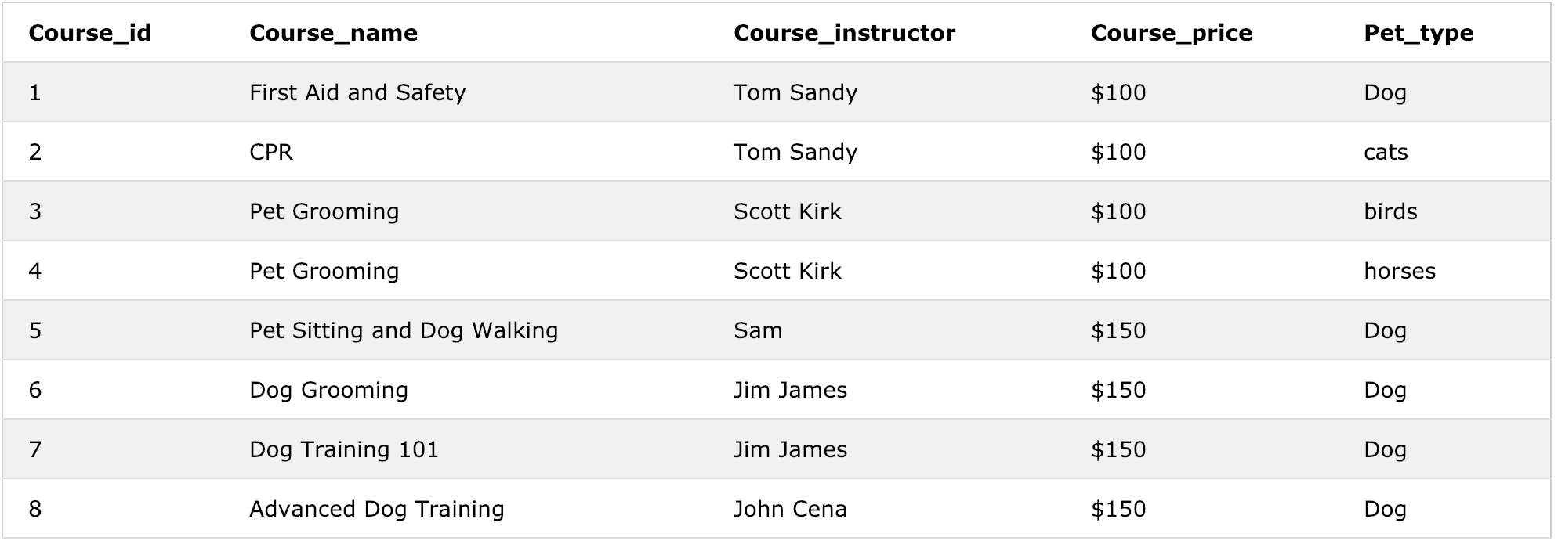

/* create table to store locations */

CREATE TABLE TRAINING_LOCATION (

Location_id int NOT NULL,

Location varchar(100) NOT NULL,

Pet_type varchar(100) NOT NULL,

CONSTRAINT TRAINING_LOCATION_pk PRIMARY KEY (Location_id)

);

/* insert sample records into trinaing_location table */

insert into training_location values (1,'New Haven','Dog');

insert into training_location values (2,'Hamden','Cat');

insert into training_location values (3,'Woodbridge','Dog');

insert into training_location values (4,'Woodbridge','Cat');

insert into training_location values (5,'Orange','birds');

insert into training_location values (6,'Orange','horses');

/* select data from trinaing_location table */

select * from training_location;

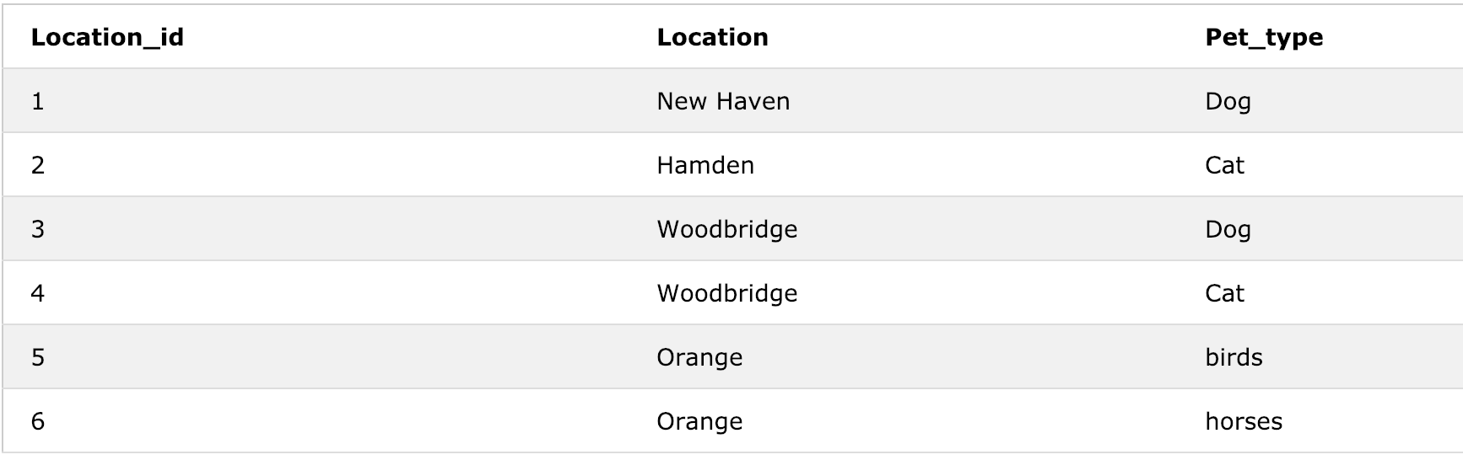

/* create Pet enrollment table */

CREATE TABLE PET_ENROLL (

Pet_id int NOT NULL,

Pet_type varchar(100) NOT NULL,

Pet_first_name varchar(100) NOT NULL,

Pet_last_name varchar(100),

Owner_ID int NULL,

Owner_firt_name varchar(100) NOT NULL,

Owner_last_name varchar(100),

CONSTRAINT PET_ENROLL_pk PRIMARY KEY (Pet_id)

);

/* insert sample records into enrollment table */

insert into pet_enroll values (1,'Dog','Dolly','D','101','Suresh','Reddy');

insert into pet_enroll values (2,'Cat','Kiity',NULL,'102','Ken','Hendry');

insert into pet_enroll values (3,'birds','sim',NULL,'103','Sam','Daly');

insert into pet_enroll values (4,'horses','Jack','Ryan','104','Noma','Kurushi');

insert into pet_enroll values (5,'Dog','Lilly',NULL,'105','Ryan','Scott');

insert into pet_enroll values (6,'horses','king','Kong','105','Ryan','Scott');

/* select the data from pet enrollment table */

select * from pet_enroll;

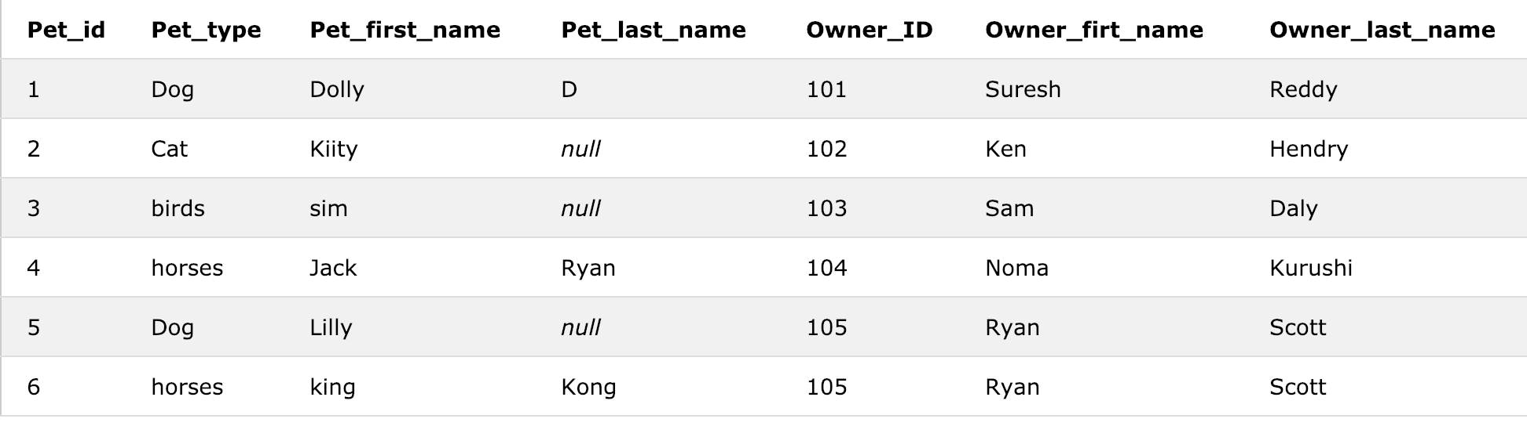

/* create Course enrollment table */

CREATE TABLE COURSE_ENROLL (

Enroll_id int NOT NULL,

Enroll_start_date date NOT NULL,

Grade varchar(10) NOT NULL,

Course_name varchar(100) NOT NULL,

Course_instructor varchar(100) NOT NULL,

Pet_first_name varchar(100) NOT NULL,

Pet_last_name varchar(100),

Owner_first_name varchar(100) NOT NULL,

Location varchar(100) NOT NULL,

Pet_type varchar(100) NOT NULL,

CONSTRAINT COURSE_ENROLL_pk PRIMARY KEY (Enroll_id)

);

/* insert sample records into course enrollment table */

insert into course_enroll values (1,'2019-01-01','PASS','First Aid and Safety','Tom Sandy','Dolly','D','Suresh','New Haven','Dog');

insert into course_enroll values (2,'2018-12-01','PASS','CPR','Tom Sandy','Kiity',NULL,'Ken','Hamden','Cat');

insert into course_enroll values (3,'2019-01-01','PASS','Pet Grooming','Scott Kirk','sim',NULL,'Sam','Orange','birds');

insert into course_enroll values (4,'2019-01-01','PASS','Pet Grooming','Scott Kirk','Jack','Ryan','Noma','Orange','horses');

insert into course_enroll values (5,'2019-01-01','PASS','Dog Grooming','Jim James','Dolly','D','Suresh','New Haven','Dog');

insert into course_enroll values (6,'2018-10-01','FAIL','Advanced Dog Training','John Cena','Lilly',NULL,'Ryan','Woodbridge','Dog');

insert into course_enroll values (7,'2018-10-01','FAIL','Pet Sitting and Dog Walking','Sam','Lilly',NULL,'Ryan','Woodbridge','Dog');

/* select data from course enrollemnt */

select * from course_enroll ;

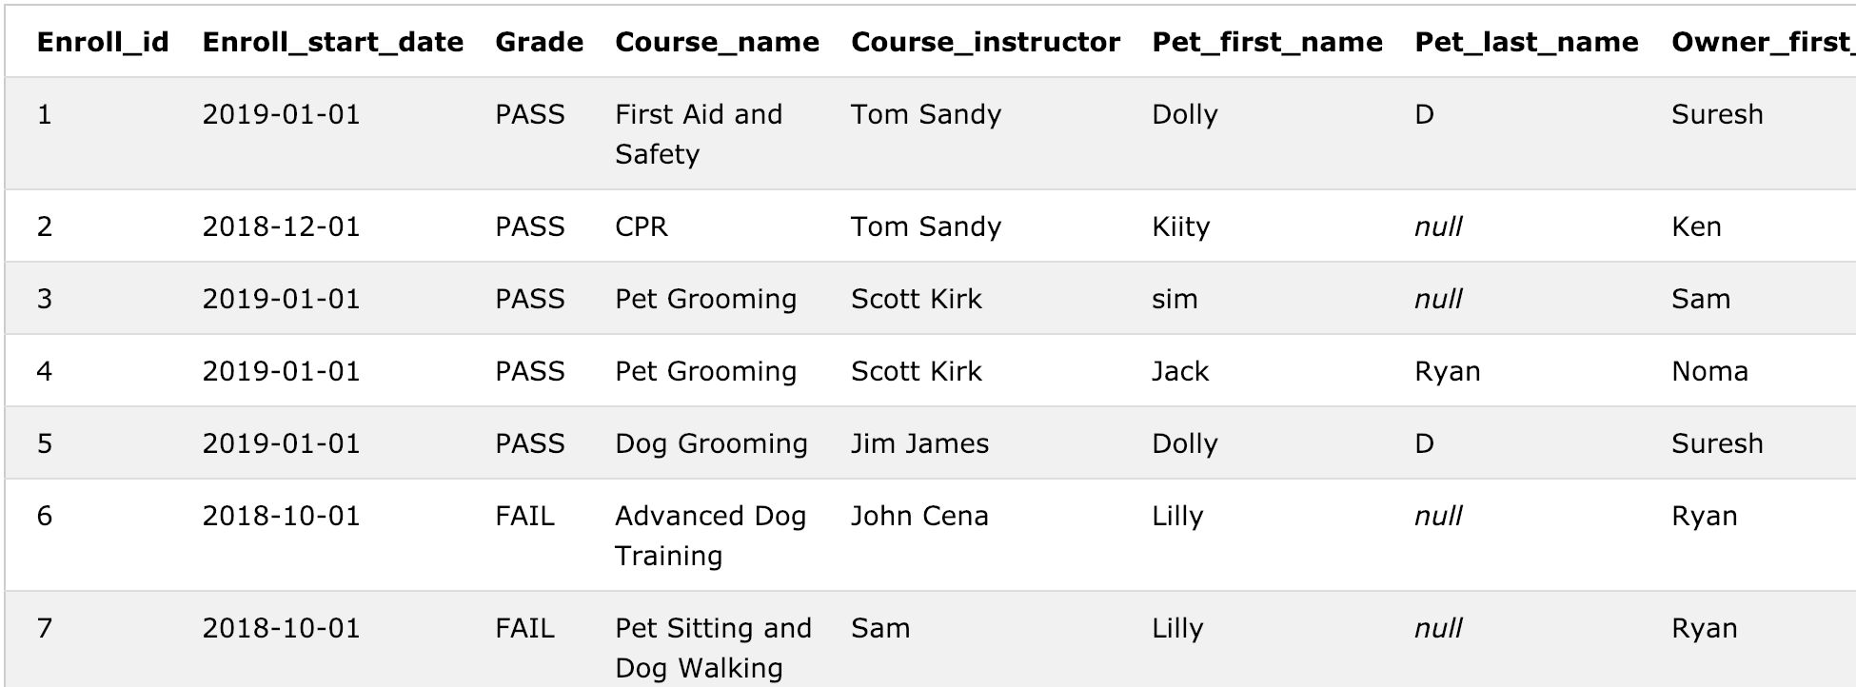

/* create the table for course hold details */

CREATE TABLE COURSE_HOLD (

Hold_id int NOT NULL,

Hold_type varchar(100) NOT NULL,

Hold_description varchar(200) NOT NULL,

Date date NOT NULL,

Course_name varchar(100) NOT NULL,

Course_Instructor varchar(100) NOT NULL,

Pet_type varchar(100) NOT NULL,

Pet_first_name varchar(100) NOT NULL,

Pet_last_name varchar(100),

Owner_first_name varchar(100) NOT NULL,

CONSTRAINT COURSE_HOLD_pk PRIMARY KEY (Hold_id)

);

/* insert the sample data into course hold table */

insert into course_hold values (1,'Financial Hold','full tuition is not paid','2018-12-10','CPR','Tom Sandy','Cat','Kiity',NULL,'Ken');

insert into course_hold values (2,'Registration Hold','registration information is missing','2018-10-10','Advanced Dog Training',

'John Cena','Dog','Lilly',NULL,'Ryan');

insert into course_hold values (3,'Vaccination Hold ','if missing vaccination information','2018-10-10','Pet Sitting and Dog Walking',

'Sam','Dog','Lilly',NULL,'Ryan');

/* select the data for course hold details */

select * from course_hold;

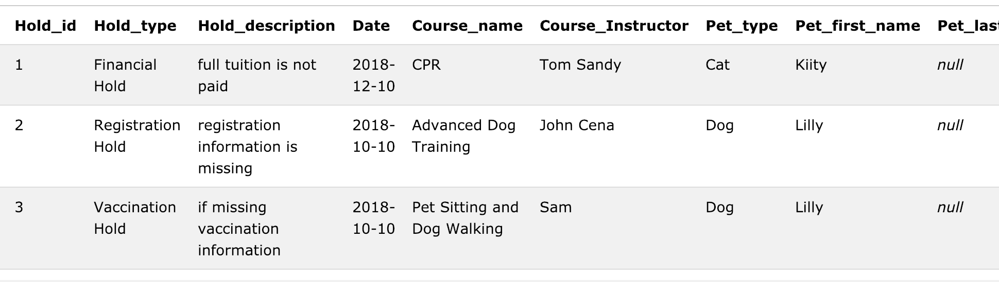

/* create the fact table to hold the Pet University details */

CREATE TABLE PET_FACT_TABLE (

Pet_id int NOT NULL,

Owner_id int NOT NULL,

Course_id int NOT NULL,

Enroll_id int NOT NULL,

Hold_id int,

Location_id int NOT NULL,

Total_amount int DEFAULT '0',

Fact_key int NOT NULL,

CONSTRAINT PET_FACT_TABLE_pk PRIMARY KEY (Fact_key)

);

/* insert the sample data based on dimension tables */

insert into PET_FACT_TABLE values (1,101,1,1,NULL,1,'$100','1001');

insert into PET_FACT_TABLE values (2,102,2,2,1,2,'$0','1002');

insert into PET_FACT_TABLE values (1,101,6,5,NULL,1,'$150','1003');

insert into PET_FACT_TABLE values (5,105,8,6,2,3,'$150','1004');

insert into PET_FACT_TABLE values (5,105,5,7,3,3,'$150','1005');

/* select the sample fact data */

select * from pet_fact_table;

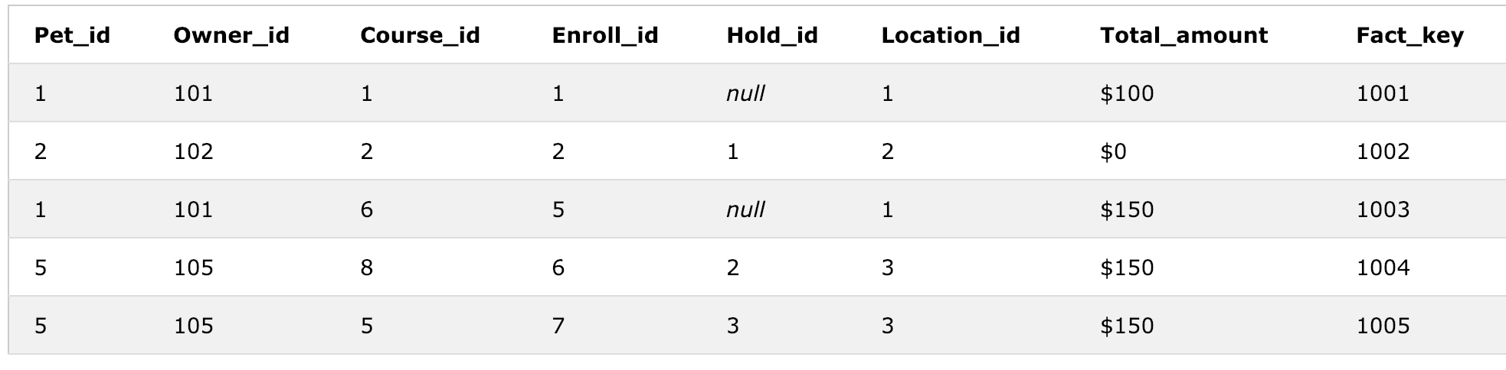

/*

1. How many new pets are enrollment in each course per month?

o Pet_first_name, Pet_last_name, Pet_type, Owner_fist_name, Owner_last_name, Enrollment_date, Month, location.

*/

select pet_dim.Pet_first_name,

pet_dim.Pet_last_name,

pet_dim.Pet_type,

pet_dim.Owner_firt_name,

pet_dim.Owner_last_name,

enrol_dim.Enroll_start_date,

extract(month from enroll_start_date) as Month,

enrol_dim.location

from PET_FACT_TABLE pet_fact

JOIN PET_ENROLL pet_dim

ON pet_fact.Pet_id=pet_dim.Pet_id

JOIN COURSE_ENROLL enrol_dim

ON pet_fact.Enroll_id=enrol_dim.Enroll_id;

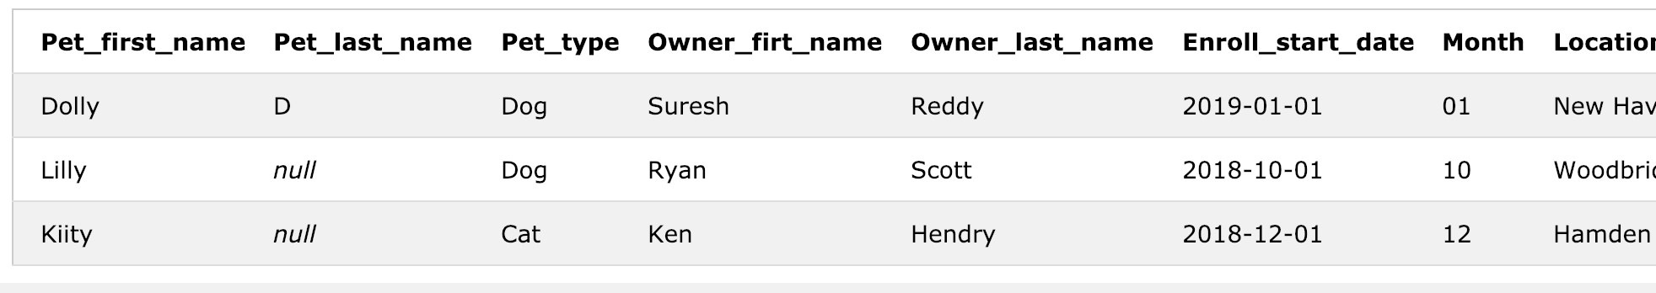

/*

2. Missing grades report?

o Pet_first_name, Pet_last_name, Owner_fist_name, Owner_last_name, course_name, course_instructor

*/

select pet_dim.Pet_first_name,

pet_dim.Pet_last_name,

pet_dim.Owner_firt_name,

pet_dim.Owner_last_name,

enrol_dim.Course_name,

enrol_dim.Course_instructor

from PET_FACT_TABLE pet_fact

JOIN PET_ENROLL pet_dim

ON pet_fact.Pet_id=pet_dim.Pet_id

JOIN COURSE_ENROLL enrol_dim

ON pet_fact.Enroll_id=enrol_dim.Enroll_id

WHERE enrol_dim.grade IS NULL /* enrol_dim.grade IS NULL ='FAIL'*/

;

/*No data as I have setup the grade data for all pets*/



/*

3. Are there holds (financial hold, vaccinations) on the pets that would prevent them from continuing with their training?

o Pet_first_name, Pet_last_name, Owner_fist_name, Owner_last_name, hold_type, hold_description, month, hold_date, course_price

*/

select pet_dim.Pet_first_name,

pet_dim.Pet_last_name,

pet_dim.Owner_firt_name,

pet_dim.Owner_last_name,

hold_dim.Hold_type,

hold_dim.Hold_description,

extract(month from hold_dim.Date) as month,

hold_dim.Date as hold_date,

course_dim.Course_price

from PET_FACT_TABLE pet_fact

JOIN PET_ENROLL pet_dim

ON pet_fact.Pet_id=pet_dim.Pet_id

JOIN COURSE_HOLD hold_dim

ON pet_fact.Hold_id=hold_dim.Hold_id

JOIN COURSE_DETAILS course_dim

ON pet_fact.Course_id=course_dim.Course_id;

